Universal Basic Income

Basil Alghamdi, haipeng Liu, Zeming Chen, Trived Katragadda, zhengxiong zouxu

2023

***Introduction***

In Boston, poverty is a persistent issue affecting a significant portion of the population. To address this, Boston City Councilor Kendra Lara has proposed a universal basic income program aimed at providing financial assistance to those in need. In support of this proposal, two projects have been initiated to analyze the economic status of families and households in Boston.

The first project's objective is to establish the selection criteria for participants in the universal basic income pilot program. This project will investigate the number of people living below the poverty line, the different levels of poverty, and the public assistance programs being used. It will also take into account the income of individuals who are not in poverty but still require monetary support. By analyzing the data, the project will provide insights into the optimal amount of money per household that can have the most significant positive impact. The primary output of this project will be a recommendation for Councilor Kendra Lara with the aim of reducing poverty levels in Boston.

The second project is focused on understanding the correlation between the population and poverty ratio in Boston over time, as well as the trend of mean and median income over the years. This project aims to examine how the population growth of Boston has affected the poverty levels in the city. The project will also analyze the mean and median income levels in Boston over the years to gain insight into how the income distribution has changed. Furthermore, as part of this project, we have also analyzed the relationship between poverty and health insurance in Boston.

The analysis will be conducted by comparing the historical data of the city's population growth and poverty ratio with the trend of mean and median income levels. The project will provide valuable insights into the relationship between population growth, income distribution, and poverty levels in Boston over the years. The findings from this project will be used to inform policy recommendations to reduce poverty and increase income equality in the city. Overall, this project will contribute to a better understanding of the economic condition of Boston and provide data-driven solutions to address poverty and inequality.

The two interconnected projects focusing on the selection criteria for a universal basic income pilot program and the correlation between population growth, poverty ratio, and income levels in Boston will significantly enhance policymakers' understanding of the city's economic conditions. The comprehensive analysis of these projects will provide valuable insights into the most effective ways to tackle the persistent problem of poverty in the city. The primary goal of these projects is to have a sustained impact on lifting people out of poverty and promoting economic equity in Boston. Together, these projects will contribute to creating a more just and equitable society in the city.

***Base analysis***

**How many people participate in assistance programs?**

* SNAP(Supplemental Nutrition Assistance Program)- 1,062,883 people– 641,911 Households

The below graph shows the distribution of people and households situated in boston.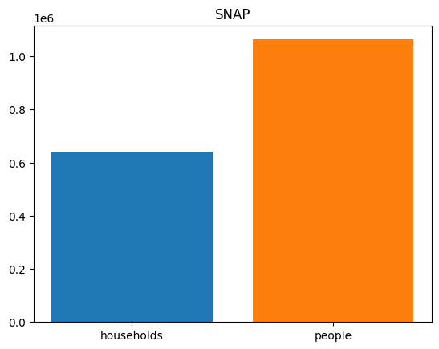

* TAFDC(Transitional Aid to Families with Dependent Children)- 99,655 people– 37,713 Households

The below graph shows the distribution of people and households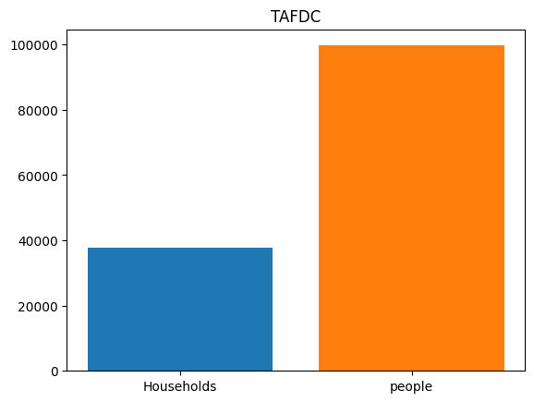

* EAEDC(Emergency Aid to Elderly, Disabled and children)- 26,592 people– 26,405 Households

The below graph shows the distribution of people and households

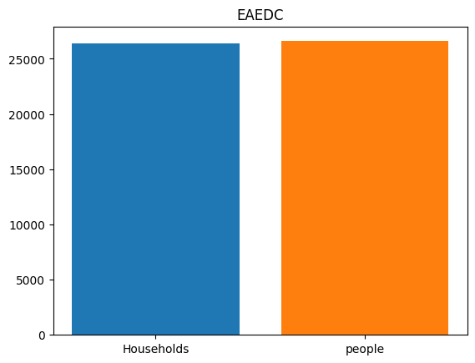

* TOTAL- 1,189,130 people– 706,029 Households

Due to the unavailability of an official dataset, we conducted research to estimate the total number of households under housing assistance and the participation rate in WIC(Women,Infants and Children nutrition program) in Massachusetts. Our findings suggest that approximately 200,000 households in the state receive housing assistance, while the participation rate in WIC is around 115,590. It is important to note that these estimates may not be exact, but they provide a rough idea of the scale of participation in these programs.

**What is the income distribution for Boston residents living below the poverty line?**

From our analysis, the income distribution of families in Boston has the following characteristics:

* Distribution is normal with a peak at 42699
* Lower bound: 37595
* Mean: 42699
* Upper bound: 47803

**What is the distribution of the poverty ratio in Boston?**

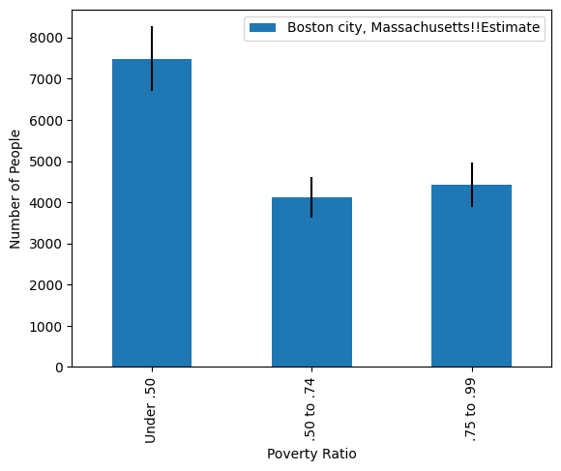

The data shows the poverty ratios in the city of Boston, Massachusetts, based on different income groups. The dataset contains information about the population estimates and margins of error for each income group.

According to the data, the highest poverty ratio is in the group of people earning under 0.50 of the poverty threshold, with an estimated 7,488 people living in poverty. The next highest poverty ratio is in the group earning between 0.50 and 0.74 of the poverty threshold, with an estimated 4,113 people living in poverty. Finally, the group earning between 0.75 and 0.99 of the poverty threshold has an estimated 4,421 people living in poverty. The poverty threshold refers to the minimum level of income deemed necessary to achieve an adequate standard of living, as determined by the government or another authoritative body. An income-poverty-ratio of 0.5 means that a household's income is 50% below the poverty threshold.

Based on this data, it is clear that there is a significant population in Boston that is living below the poverty line. This information can be used by policymakers and community organizations to target resources and programs for these vulnerable groups in order to alleviate poverty and promote economic development.

**Any interesting correlations between family size and the poverty threshold?**

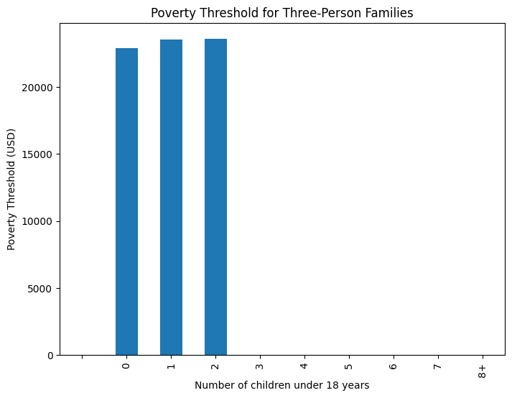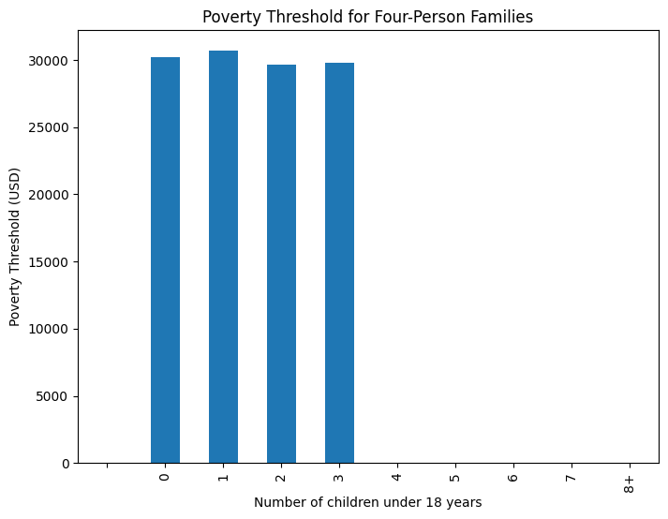

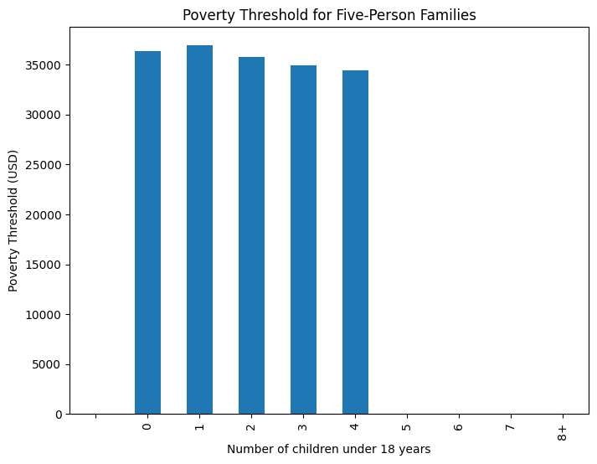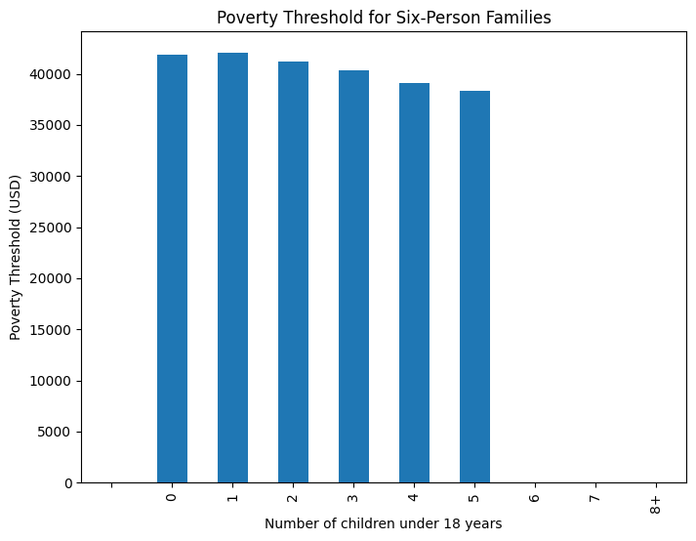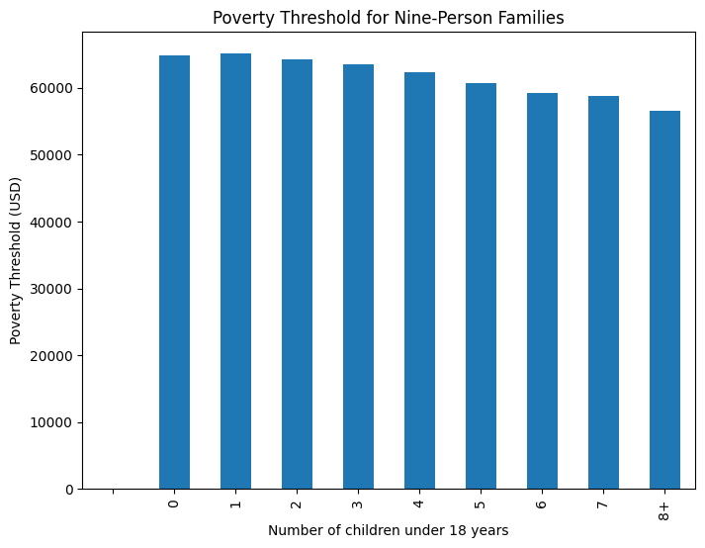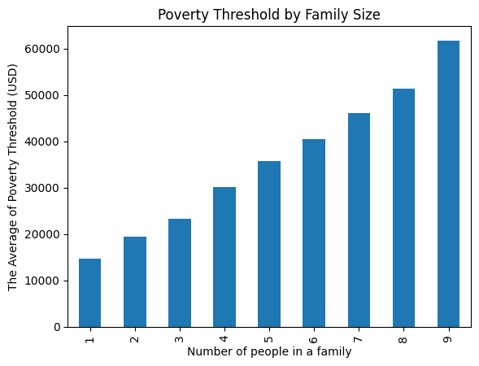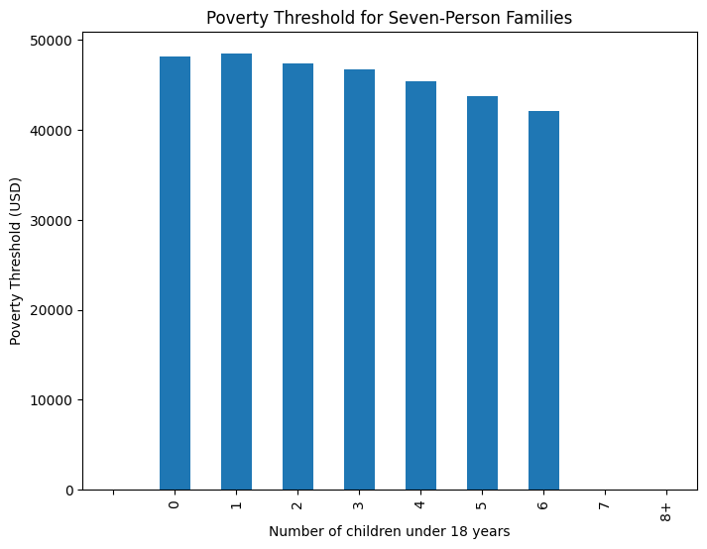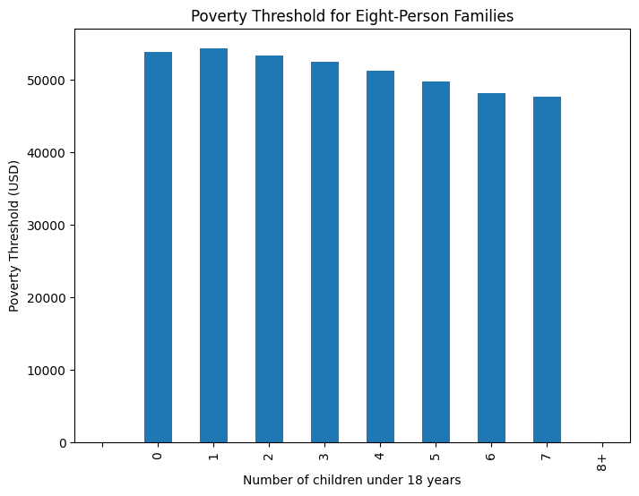

From the plot, we can see that there is a general trend of higher poverty levels for larger

families. This makes sense since larger families have more mouths to feed and may have more difficulty making ends meet. And we can also notice that the fewer children under 18, the higher the poverty levels are. This makes sense that the fewer children under 18, the more adults work to earn money so that the poverty levels are higher. However, these trends are not perfectly linear, and there are some fluctuations in the data. It would be interesting to further investigate these fluctuations to see if there are any other factors that may be influencing the poverty levels for certain family sizes.

**How many people/individuals/families are significantly below the poverty line**

**Statistical way: bottom 5%, 10%, 15% of families within the fams that are already under the poverty line?**

Here are some Stats:

------------------------------

Massachusetts:

Total families: 1,719,532

Poverty rate: 7.1%

Married-couple families: 1,268,347

Married-couple families poverty rate: 3.4%

Female householder, no spouse present families: 327,491

Female householder, no spouse present families poverty rate: 20.2%

Boston city, Massachusetts:

Total families: 121,536

Poverty rate: 13.7%

Married-couple families: 74,624

Married-couple families poverty rate: 7.3%

Female householder, no spouse present families: 36,475

Female householder, no spouse present families poverty rate: 27.9%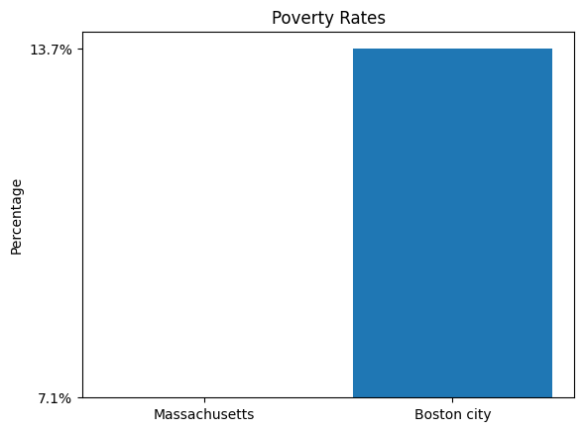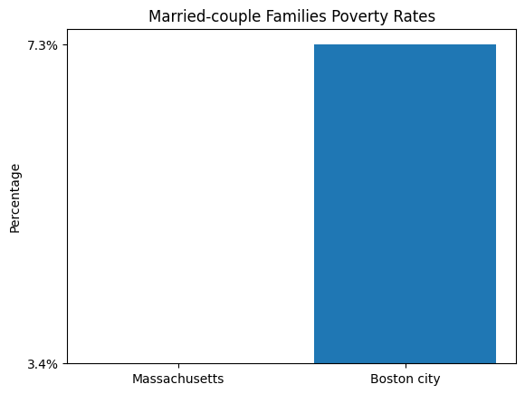

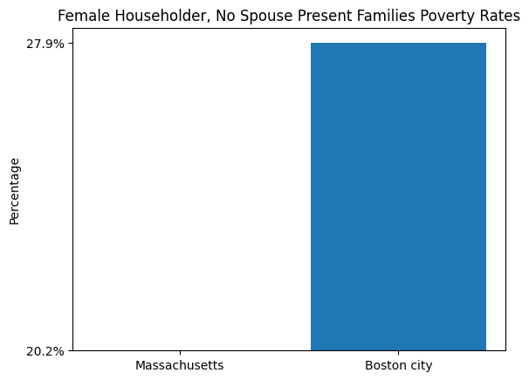

The graphs display three bar plots comparing:

- Poverty rates in Massachusetts and Boston city.

- Married-couple families' poverty rates in Massachusetts and Boston City.

- Female householders, no spouse present families poverty rates in Massachusetts and Boston city.

To analyze how many families are significantly below the poverty line, we can define a threshold for "significantly below" as the bottom X% of families within the families already under the poverty line. In this case, we'll calculate the bottom 5%, 10%, and 15%.

However, since the given data doesn't provide income information for individual families, we cannot accurately determine the number of families falling within these percentages. In order to perform this analysis, we would need more detailed data, such as individual family incomes or income brackets.

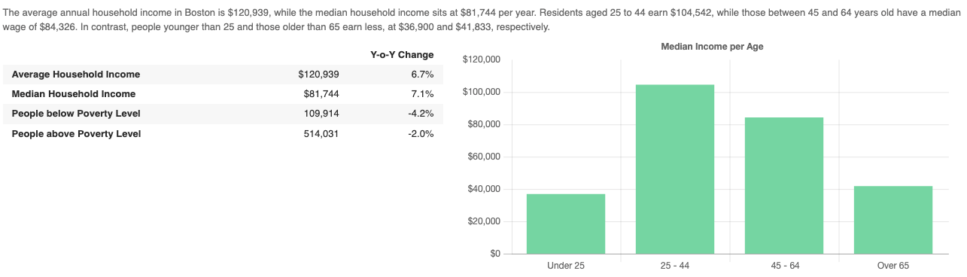

**What is the total population for different income groups?**

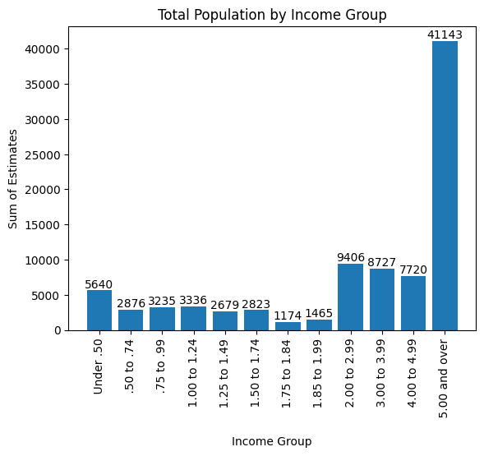

The ratio under .50 contains 11280 families, while .50 to .74 only contains 5752, just nearly half of the ratio under .50. And the ratio .75 to .99 contains 6470 families.

***Extension analysis***

* **What is the correlation between population and poverty ratio over the years?**

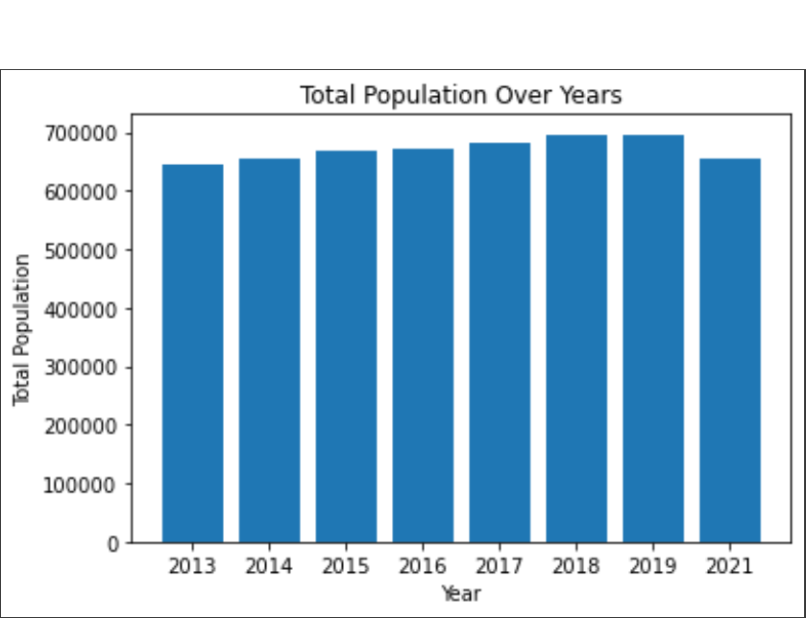

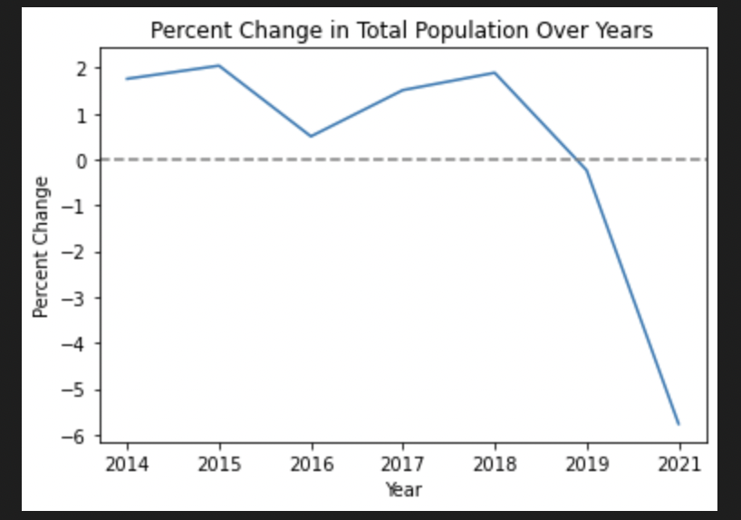

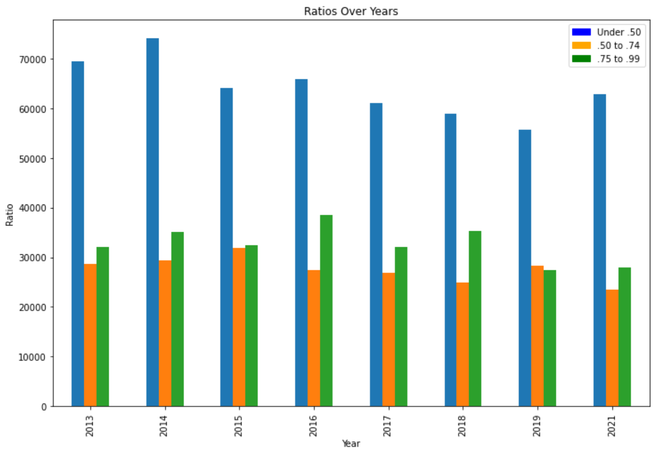

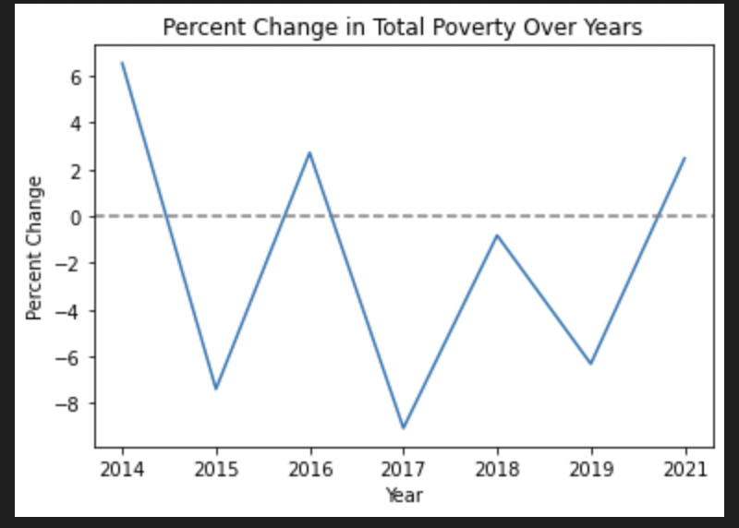

The graph above shows the number of people and their poverty ratios over the years.

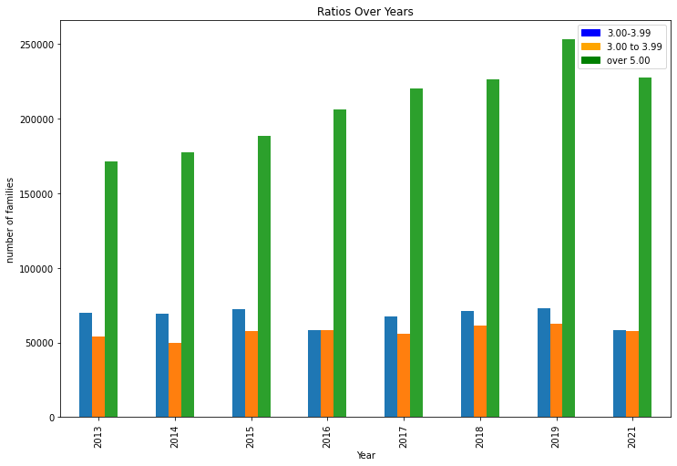

And from this graph, we can see that the rich people become even more rich. Except 2021(maybe due to the Covid 19)

It seems that between 2013 and 2019, the population of Boston increased steadily from 650,000 to around 700,000. During the same period, the poverty rate remained relatively stable. This might suggest that population growth did not have a significant impact on the poverty rate during those years.

However, in 2021, there was a decrease in the population. Several factors could have contributed to this decline, such as economic conditions, migration patterns, or the impact of the COVID-19 pandemic. It is worth noting that even with the population decrease, the poverty rate remained relatively stable but a very minor increase, indicating that other factors might be at play in maintaining the poverty rate.

**What is happening for the mean and median income over the years?**

Here are some statistics:

Year: 2013 Year: 2014

Median Earnings: 32,142 Median Earnings: 35,273

Mean Earnings: 70,418 Mean Earnings: 74,406

Year: 2015 Year: 2016

Median Earnings: 36,059 Median Earnings: 37,323

Mean Earnings: 73,968 Mean Earnings: 77,240

Year: 2017 Year: 2018

Median Earnings: 38,884 Median Earnings: 41,125

Mean Earnings: 79,642 Mean Earnings: 83,904

Year: 2019 Year: 2021

Median Earnings: 45,046 Median Earnings: 49,039

Mean Earnings: 87,885 Mean Earnings: 99,604

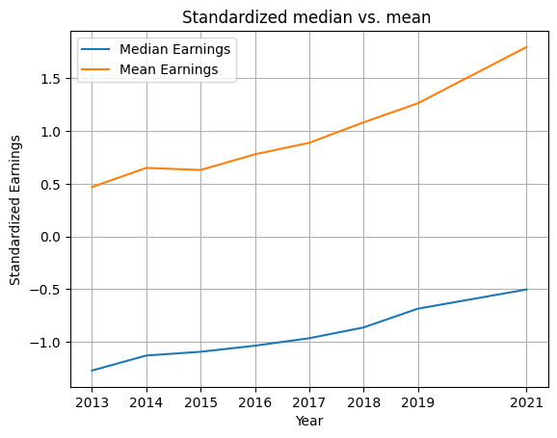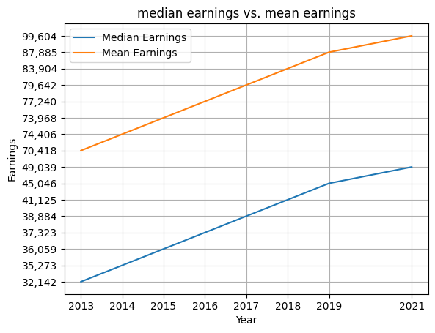

The standardized results are indeed different from the original results. Standardization is a preprocessing technique that adjusts the scale of a dataset so that each feature has a mean of 0 and a variance of 1. This method can help us more easily compare features of different scales and, in some cases, make machine learning algorithms work more effectively. However, this also means that the standardized data may no longer have the same original units and range.

In this example, we have standardized the earnings data, so the vertical axis (standardized earnings) now represents the number of standard deviations that the original earnings data is from the average earnings of the entire dataset. This is the reason why the standardized results are different from the original results. The purpose here is to help you more easily observe the relative changes in the data, rather than focusing on the absolute values of the original earnings.

* **Percentage of Individuals with Poverty Ratios Below 100% by Nativity and Citizenship Status:**

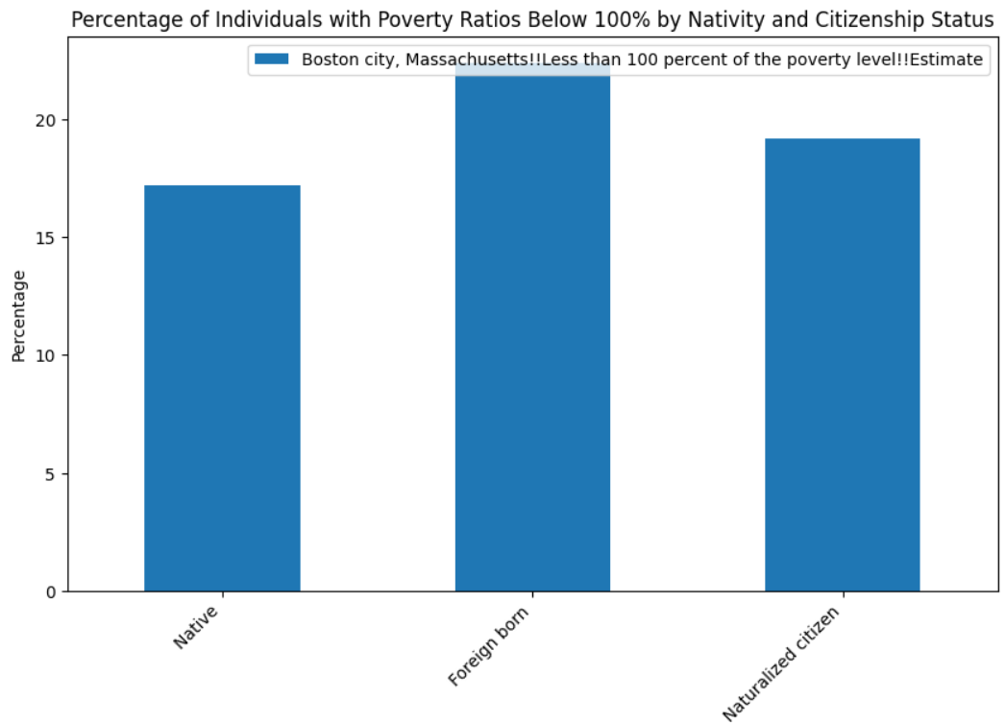

This graph shows the percentage of individuals with poverty ratios below 100% based on their nativity and citizenship status. We can observe that foreign-born individuals have a higher percentage of people living below the poverty line (22.4%) compared to native individuals (17.2%). Among foreign-born individuals, non-citizens have a higher poverty rate (22.4%) than naturalized citizens (19.2%). When comparing these findings to the percentages of individuals living below 50% of the poverty level, the same trend is observed, with foreign-born individuals and non-citizens having higher poverty rates. Definition of The foreign-born population includes **anyone who was not a U.S. citizen at birth**. This includes respondents who indicated they were a U.S. citizen by naturalization or not a U.S. citizen.

* **Percentage of Individuals with Poverty Ratios Below 100% by Disability Status:**

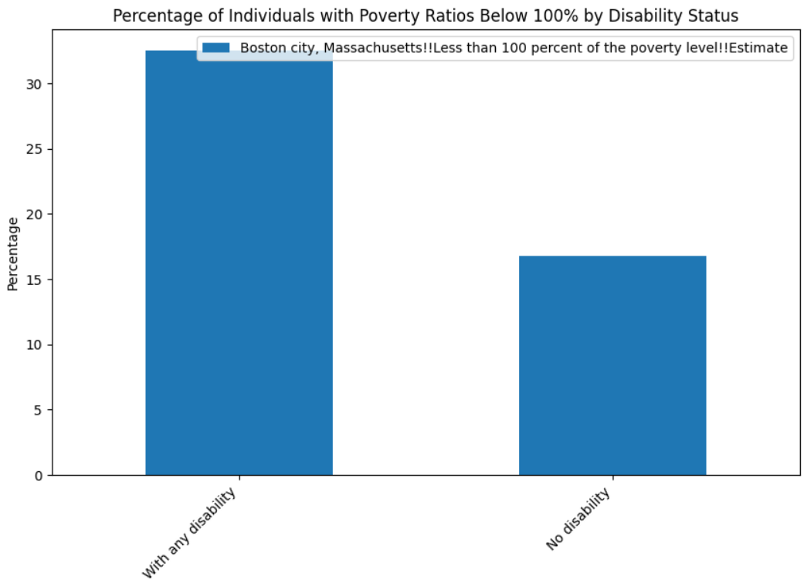

In this graph, we can see the impact of disability status on the poverty ratio. Individuals with any disability have a significantly higher percentage of people living below the poverty line (32.5%) compared to those without a disability (16.8%). This indicates that disability is a significant factor in poverty levels. When comparing these percentages to the less than 50% poverty level graph, the same pattern is evident. Individuals with disabilities face more significant challenges in escaping poverty compared to those without disabilities.

* **Percentage of Individuals with Poverty Ratios Below 100% by Work Status:**

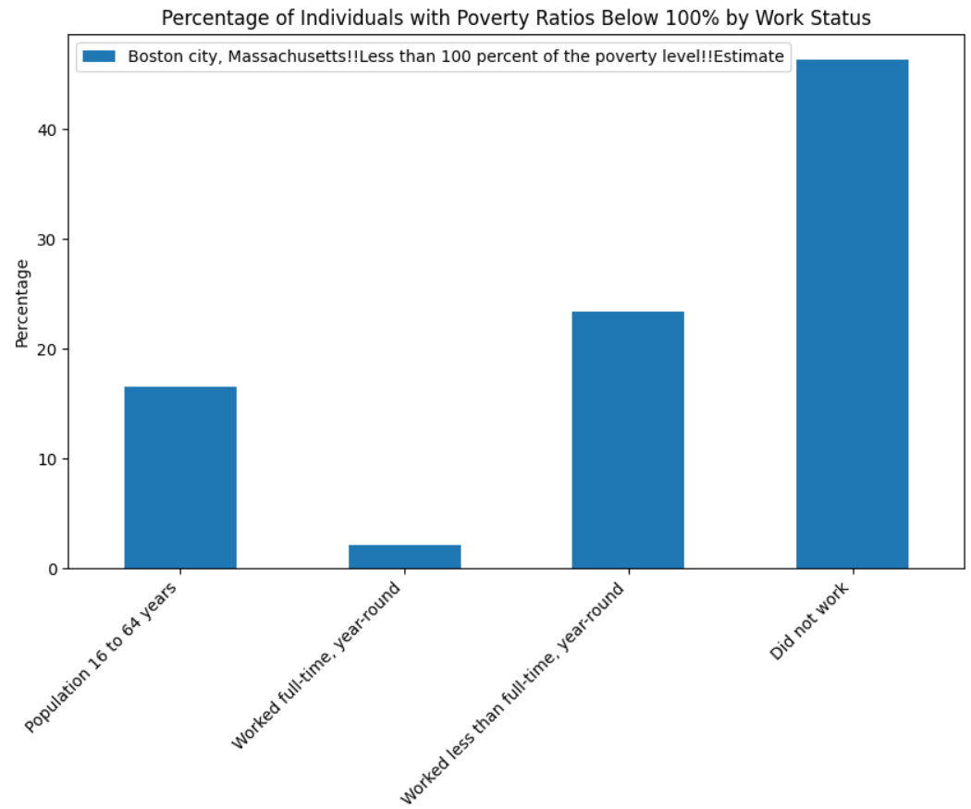

The graph displaying the percentage of individuals with poverty ratios below 100% based on their work status shows a clear relationship between work status and poverty levels. Individuals who did not work have the highest poverty rate (46.3%), followed by those who worked less than full-time, year-round (23.4%). People who worked full-time, year-round have the lowest poverty rate (2.1%). Comparing these findings to the percentages of individuals living below 50% of the poverty level, we see a similar trend, with the highest poverty rate among those who did not work, followed by those who worked less than full-time, year-round. Full-time, year-round workers have the lowest poverty rate in both cases.

* **Relationship between health insurance with poverty:**

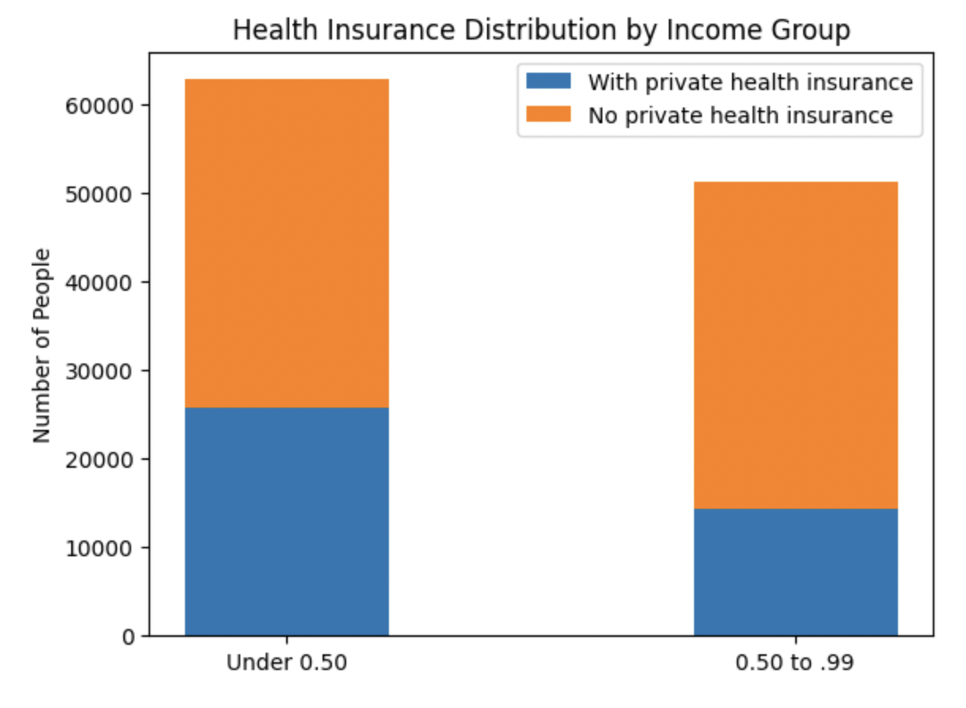

The relationship between poverty and health insurance is complex, as lower-income individuals often face greater barriers to obtaining private health insurance. High insurance premiums force many to prioritize other essential needs, such as housing, food, and education, over health insurance coverage. Without proper coverage, individuals are less likely to seek timely medical care, resulting in delayed diagnoses and treatments, exacerbating existing health disparities.

To mitigate the impact of poverty on health insurance coverage, policymakers must explore and implement more affordable and accessible healthcare options for lower-income populations. Possible solutions include expanding public health insurance programs, providing subsidies for private health insurance, and investing in community-based healthcare initiatives targeting underserved populations. Addressing the link between poverty and health insurance can help reduce health disparities and improve overall health and well-being for all individuals, regardless of income.

* **Private health insurance coverage by income group and age**

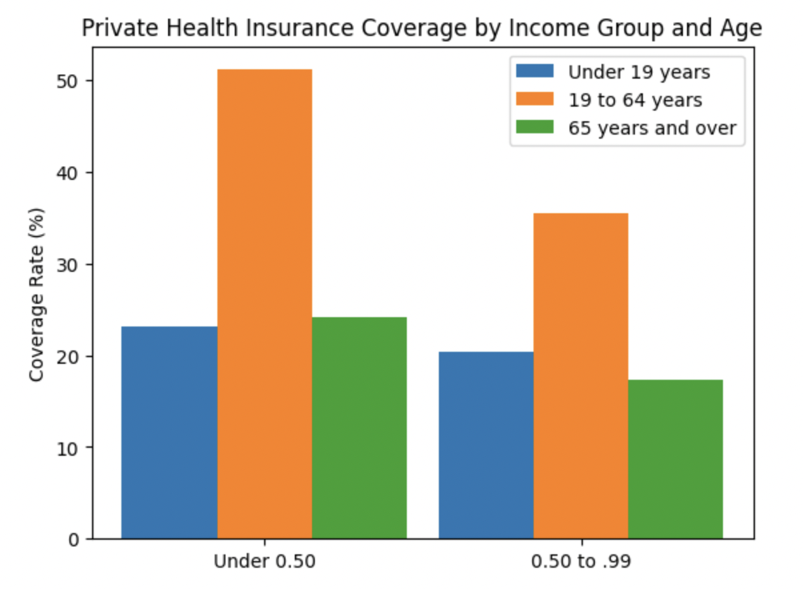

The relationship between private health insurance coverage and income group is critical in understanding the disparities in access to healthcare. Individuals below the poverty line tend to have lower private health insurance coverage rates compared to those with higher incomes. This disparity is partly due to the cost of premiums, which can be prohibitively expensive for low-income individuals, leaving them uninsured or underinsured. Consequently, these individuals may not have access to the same range of healthcare services as their higher-income counterparts, leading to poorer health outcomes and exacerbating existing inequalities.

Age also plays a significant role in health insurance coverage, as older individuals generally require more healthcare services and have higher healthcare costs. Although many countries have public health insurance programs that cater to older citizens, the coverage may not always be comprehensive or may be limited in scope. As a result, older individuals, particularly those with lower incomes, may face difficulties in obtaining adequate private health insurance coverage, further widening the gap between income groups in terms of access to healthcare. Addressing these disparities requires concerted efforts from both the public and private sectors to ensure that vulnerable populations, including low-income and older individuals, have access to affordable and comprehensive health insurance coverage.

* **Conclusion on Extention Analysis:**

In conclusion, our extension analysis has revealed several critical insights into the correlation between population and poverty ratios in Boston over the years. We have observed that median and mean earnings have generally increased over time, indicating an improvement in the overall economic situation. However, it is important to recognize that certain groups within the population are disproportionately affected by poverty. Specifically, foreign-born individuals, particularly non-citizens, and individuals with disabilities face higher poverty rates compared to their native and non-disabled counterparts. Work status is also a significant factor influencing poverty levels, with the highest poverty rates found among those who did not work and the lowest among full-time, year-round workers. Furthermore, regarding the relationship between poverty and health in Boston, policymakers must prioritize implementing more accessible and affordable healthcare options. This will contribute to better health outcomes and a more equitable society for all, regardless of income.

These findings mark the importance of understanding the complex relationship between population, poverty, and various socio-economic factors. Addressing these disparities requires targeted policies and interventions to support vulnerable populations and create more equitable opportunities for all. This analysis serves as a valuable starting point for further research and policy development aimed at reducing poverty and promoting economic growth in Boston and beyond.

***Contributions***

Basil Alghamdi: coded, analyzed two questions, wrote deliverable 1, wrote most of the mid-presentation slides, presented the slides to the client, and wrote the whole report draft. Also coded and analyzed part of the extension analysis. Added slides to the final presentation slides and presented them to the client. Finalized the final draft.

haipeng Liu: wrote the code of 5 questions, wrote deliverable1, and wrote some of the mid presentation slides, wrote the whole final presentation slides and presented the slides to the client, also helped to write the final report.

Zeming Chen: coded and analyzed 2 questions, helped with presentations, wrote part of the extended analysis and help finalizing the report.

Trived Katragadda: Have done most of the coding part for Delivarable 1 and helped the teammates with their part of analysis, helped with the documentation.

zhengxiong zouxu: (to be specified later)